PROJECT PLANNING TEMPLATE
Product Backlog, Sprint Plan, User Stories and Story Point Estimation
The Project Planning Phase includes preparing the Product Backlog, Sprint Plan, User Stories, and Story Point estimation. It helps the team organize the project into smaller and manageable tasks.
Date: 28.09.2026
Team ID: __________
Project Name: legalEase
Maximum Marks: 5 Marks

1. Product Backlog, Sprint Schedule and Estimation
A Product Backlog is a list of all the features and tasks that need to be completed in a project. These tasks are divided into Epics and User Stories. Each User Story is assigned Story Points based on the amount of effort required.
Sprint | Functional Requirement (Epic) | User Story Number | User Story / Task | Story Points | Priority | Team Members
Sprint-1 | Registration | USN-1 | As a user, I can register for the application by entering my email, password, and confirming my password. | 2 | High
Sprint-1 | Registration | USN-2 | As a user, I will receive a confirmation email after registering for the application. | 1 | High
Sprint-2 | Registration | USN-3 | As a user, I can register for the application through Facebook. | 2 | Low
Sprint-1 | Registration | USN-4 | As a user, I can register for the application through Gmail. | 2 | Medium
Sprint-1 | Login | USN-5 | As a user, I can log into the application by entering my email and password. | 1 | High
— | Dashboard | — | Dashboard-related tasks | — | —

Meaning of the Columns
- Sprint: The period in which the User Story is planned to be completed.
- Functional Requirement (Epic): A major feature or function of the application.
- User Story Number: A unique identification number for each User Story.
- User Story / Task: Describes what the user should be able to do.
- Story Points: Represents the effort or complexity required to complete the task.
- Priority: Shows how important the User Story is, such as High, Medium, or Low.
- Team Members: The team members responsible for completing the task.

2. Project Tracker, Velocity and Burndown Chart
A Project Tracker is used to monitor the progress of each Sprint. It records the planned Story Points, Sprint duration, dates, and the number of Story Points actually completed.
Sprint | Total Story Points | Duration | Sprint Start Date | Sprint End Date (Planned) | Story Points Completed | Sprint Release Date (Actual)
Sprint-1 | 20 | 6 Days | 24 Oct 2022 | 29 Oct 2022 | 20 | 29 Oct 2022
Sprint-2 | 20 | 6 Days | 31 Oct 2022 | 05 Nov 2022 | — | —
Sprint-3 | 20 | 6 Days | 07 Nov 2022 | 12 Nov 2022 | — | —
Sprint-4 | 20 | 6 Days | 14 Nov 2022 | 19 Nov 2022 | — | —

3. Velocity
Velocity is the amount of work, measured in Story Points, that a team completes during one Sprint.
For example, suppose:
- Sprint duration = 10 days
- Team velocity = 20 Story Points per Sprint
To find the Average Velocity (AV) per day:
Average Velocity = Story Points per Sprint ÷ Sprint Duration
- AV = 20 ÷ 10
- AV = 2 Story Points per day
Therefore, the team completes an average of 2 Story Points per day during the Sprint.

4. Burndown Chart
A Burndown Chart is a graph that shows the amount of work remaining in a project or Sprint over time. It helps the team understand whether the work is being completed according to the planned schedule.
- The horizontal axis (X-axis) represents time, such as days in a Sprint.
- The vertical axis (Y-axis) represents the amount of work remaining, usually measured in Story Points.
- As the team completes tasks, the remaining Story Points decrease.
- Ideally, the graph moves downward toward zero by the end of the Sprint.
For example, if a Sprint starts with 20 Story Points, the amount of remaining work should gradually decrease as tasks are completed.
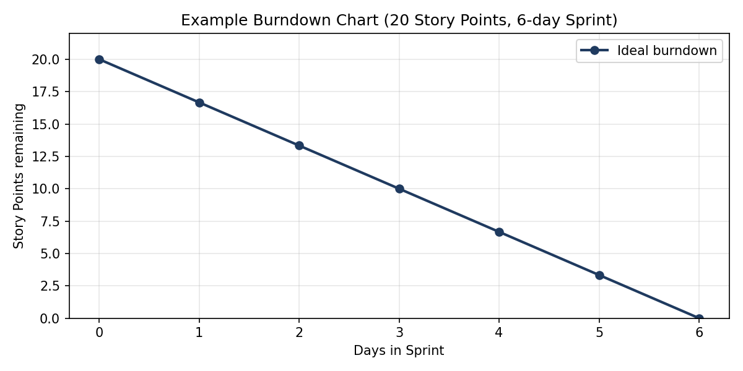

Conclusion
The Project Planning Phase helps the team organize the project into manageable Epics and User Stories, estimate the required effort using Story Points, assign priorities, and schedule the work across Sprints.
The Project Tracker monitors progress, Velocity measures the team's average completed work, and the Burndown Chart shows how much work remains during the Sprint.

